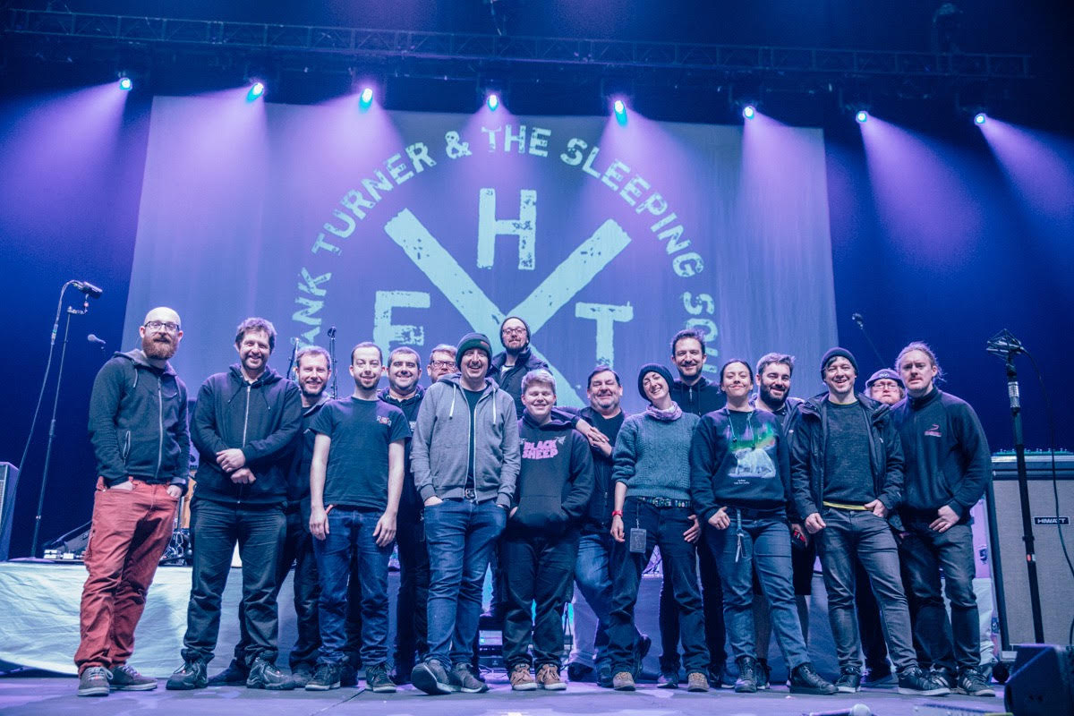
Frank Turner’s crew. Photo credit: Ben Morse

Frank Turner reunites with The Sleeping Souls for live stream show

Long-time Sennheiser user Frank Turner hosts live-stream concert on 9th August in support of his touring family

Marlow, August 6, 2020 — Having streamed a host of solo shows during lockdown, award-winning British folk singer-songwriter, Frank Turner is finally back with his band, The Sleeping Souls, and is set to perform an hour-long, live streamed gig via Dice.fm on 9th August 2020.

“I'm very excited for the show on Sunday, August 9th, for a bunch of reasons,” he says. “Firstly, it's the first time I'll be seeing and playing with my band since lockdown started; having the full range of musicians and instruments will be a nice change from playing solo to my phone. Secondly, my crew have put together an amazing production for the show, with help from our friends at Sennheiser; top quality audio, video and lighting. And finally, it'll be my 2,500th show - one for the history books. I can't wait.”

Turner is a long-time Sennheiser user and, on the recommendation of his production manager Dougie Murphy and Sennheiser’s Andy Egerton, switched to its Digital 6000 system for his successful UK tour in support of his album No Man’s Land earlier this year. Since then, like the majority of the entertainment industry Turner and his crew have been hit hard by the pandemic crisis, with all their shows cancelled and no work on the horizon for the foreseeable future.

Production for the live stream, which aims to raise money for Turner’s touring family, will be taken care of by Murphy and four crew members, performed in front of a socially distanced audience and delivered in full broadcast quality, with Sennheiser showing its support for the event by providing additional equipment needed.

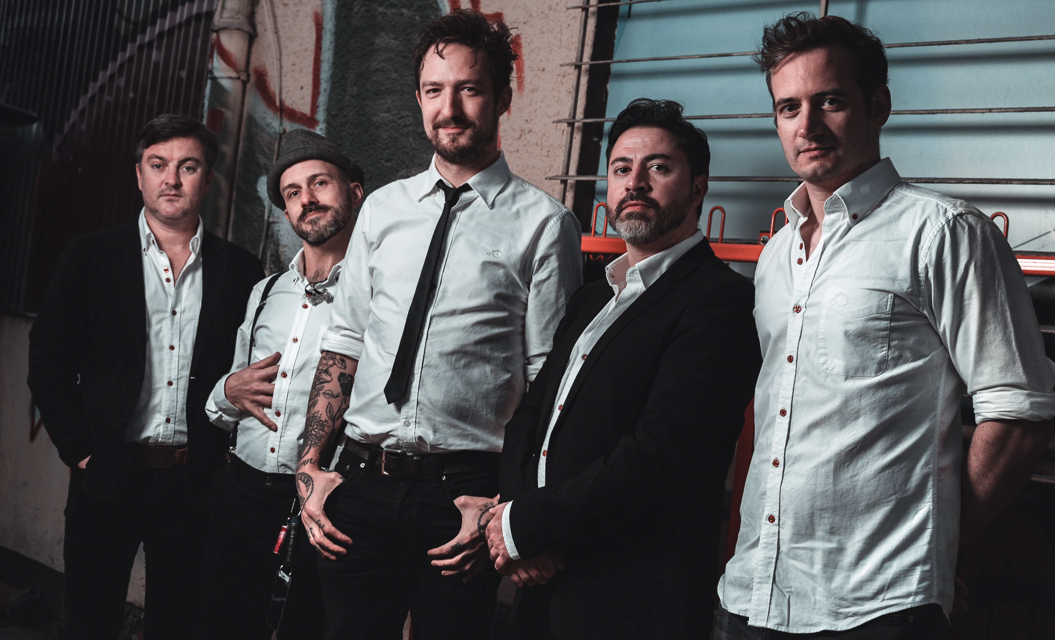
Frank Turner and The Sleeping Souls
Photo credit: Lukas Rauch Photography

“Frank is not only helping his own touring family, he’s working incredibly hard to raise awareness of the dire situation the live entertainment industry is in,” comments Egerton. “Amongst other things, he gave his time for free to participate in a government-backed pilot a few weeks ago to determine the viability of playing to a socially distanced audience, and also participated in Sennheiser’s video in support of PLASA’s #WeMakeEvents campaign. We are delighted and proud to be able to lend him our support for this event.”

The general hope for the pilot, which was held at the Clapham Grand in London, was that could provide a blueprint for the entertainment industry, meaning that live music events could restart. All necessary safety measures were put in place, with seating and tables brought into the venue to adhere to the strict social distancing rules, as well as gig-goers arriving at staggered intervals to have their temperature checked, and sanitary precautions put in place to ensure a safe environment for everybody.

According to Turner, the event was his “first proper gig in over four months”. He described it as a “strange, emotional evening”. However, it became clear that playing to 200 socially distanced attendees (the venue’s normal capacity is 1,250) was not financially viable and would not prove to be a model the industry could move forward with.

On a positive note, Turner, his band and crew will be pulling out all the stops for the live stream and giving an extra 24hrs viewing time online for the one-hour gig.

Tickets for the show, which starts at 9pm this Sunday, are still available and can be purchased via Dice here and will be streamed from Vans For Bands maintenance workshop in Oxford in association with Xtrasonic Media and Xtra Mile Recordings.

About Sennheiser
Founded in 1945, Sennheiser is celebrating its 75th anniversary this year. Shaping the future of audio and creating unique sound experiences for customers – this aim unites Sennheiser employees and partners worldwide. The independent family company, which is managed in the third generation by Dr. Andreas Sennheiser and Daniel Sennheiser, is today one of the world’s leading manufacturers of headphones, loudspeakers, microphones and wireless transmission systems. In 2018, the Sennheiser Group generated turnover totalling €710.7 million. www.sennheiser.com

Local Press Contacts

Sarah James Maik Robbe
sarahj@gasolinemedia.com maik.robbe@sennheiser.com
+44 (0) 1483 223333 +44 (0) 7393 462484

Notes to the Editor:

From major festivals being cancelled to landmark theatres and grassroots venues going dark, the entire live entertainment and events industry has been financially devastated by the COVID-19 crisis, with hundreds of thousands of highly skilled industry professionals having had no work for the past five months and with little likelihood of restarting until Spring 2021.
Sennheiser is supporting the #WeMakeEvents initiative, helping to raise awareness of those individuals and companies affected by the crisis.
Together, we can make our industry’s voice heard. Please visit https://lnkd.in/epp3sNb for more info and how you can help.

